YS-174 Bluetooth Player Instructions for use

Thank you for using this Bluetooth player, which has the following features.

1. Easy to operate, powerful sound, combines Radio, Bluetooth, Audio/(MP3) input in one.
2. Strong applicability, wide compatibility; suitable for a variety of mobile phones, can be used with mobile phones, TV or other audio devices interoperable.
3. Realize the left and right channel output, enhance the entertainment and leisure dynamic.
4. Widely used in swimming pools, spas, sauna / steam rooms and outdoor pavilions etc.

I. Panel keys.
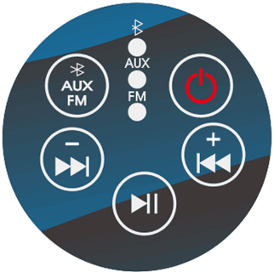
- (Bluetooth power on/off)
- (Menu function keys <Radio, Bluetooth, AUX keys>)
- (Sound plus/previous song)
- (sound minus/next song) VOL+ key (sound plus)
- (Play pause)
- (Blue light on for Bluetooth, green light for AUX, red light for radio)

II. Wiring terminals.
1. The panel's power supply DC12V (internal positive and external negative) connection cable can be connected with DC power supply DC12V / 1A
2. The panel's AUX audio input left and right channel connection cable can be used with audio signal.
3. The panel's left and right channel audio output connection cable can be used with amplifier input signal.
4. 1meter long antenna

III. Operating instructions.
1. Indicator button
Press, power on, the indicatorfirst light blue and enter into the voice Bluetooth state;
Press, the indicator blue light off and green light on, and enter into the voice Audio (AUX) state; Press, the indicatorgreen light off and red light on, and enter into the voice Radio (FM) state; Presskey, it will cycle and so on.
- AUX FM button
2.1 In the voice Bluetooth state, code with your smartphone with the player YS-174, then you can play the music on smartphone, short press / to select the music, long press and hold / to adjust the volume up / down.
2.2 In the voice Audio (AUX) state, when play the music, long press and hold / to adjust the volume up / down.
3.3 In the voice Radio (FM) state, long press and hold the key , the current red light flashes and the radio channel is automatically searched and stored until the search is completed; short press the key / to select your favourite music; long press and hold / to adjust the volume up / down.

IV. Basic parameters
1.Left and right channel output power 2*10 watts.
2.DC-12V5A for power supply.

V. Matching products with this player
1.Left and right channel 2 inch speaker speakers 2*4(/8) Ω 3 watts / 3 inch speaker speakers 2*4(/8) Ω 10 watts (optional)
2.power supply with DC-12V 8.5A two-way output (can be connected to the player and TV or other audio equipment)

